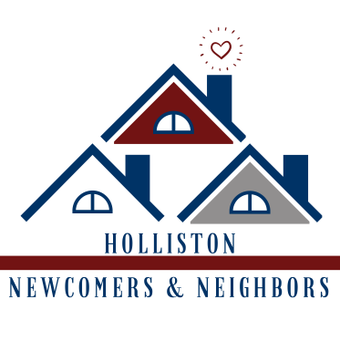
HNN Annual Sponsorship Tiers (2024 calendar year)

Gold $1000
- Named as an EVENT SPONSOR for ALL HNN Fundraising Events in all marketing materials
- A FEATURE POSTER at ALL in-person HNN Fundraising Events identifying your business as an EVENT SPONSOR
- Information table or other approved presence at all in-person HNN Fundraising Events
- Admission to ALL HNN Fundraising Events for 1 family (up to 4 immediate members for children’s events or up to 2 tickets for adult events)
  - 1 Item for non-admission events - for example Prize-A-Day would be 1 Calendar
- Recognition & Business logo on our Club Website home & sponsor pages and in our member newsletter
- Recognition & Business logo on our Club Sponsor Poster at Celebrate Holliston & select member events
- Recognition as a club sponsor on HNN Social Media

Silver $500
- Information table or other approved presence at all in-person HNN Fundraising Events
- Admission to 1 HNN Fundraising Event of your choosing for 1 family (up to 4 immediate members for children’s events or up to 2 tickets for adult events)
  - 1 Item for non-admission events - for example Prize-A-Day would be 1 Calendar
- Recognition & Business logo on our Club Website home & sponsor pages and in our member newsletter
- Recognition & Business logo on our Club Sponsor Poster at Celebrate Holliston & select member events
- Recognition as a club sponsor on HNN Social Media

Bronze $250
- Recognition & Business logo on the HNN Website home & sponsor pages and in our member newsletter
- Recognition & Business logo on our Club Sponsor Poster at Celebrate Holliston & select member events
- Recognition as a club sponsor on HNN Social Media

Building Friendships, Building Community
----------------------------------------------------------------------------------------------------------------------------------------------------
To register your sponsorship, return this portion with a check made out to Holliston Newcomers & Neighbors to:

Holliston Newcomers & Neighbors
Sponsorship
PO Box 6581, Holliston MA 01746

Sponsorship Level (circle): Gold ($1000) Silver ($500) Bronze ($250)
Company Name:__________________________________________________________________________
Mailing Address:__________________________________________________________________________
Contact Name:____________________________ Contact Email:__________________________________
www.hollistonnewcomers.org | P.O. Box 6581, Holliston MA 01746 | EIN: 04-2627413

